**Project Title:** AI-Powered Cold Email Outreach Bot

**Brief Description:** Developed an AI-driven Cold Email Outreach Bot designed to optimize email marketing campaigns by automating the process of scraping targeted emails from LinkedIn and crafting personalized cold emails. This bot leverages PhantomBuster for email scraping and OpenAI's ChatGPT for generating engaging subject lines and email bodies. The solution ensures that each email is tailored to the recipient, enhancing the likelihood of engagement and response.

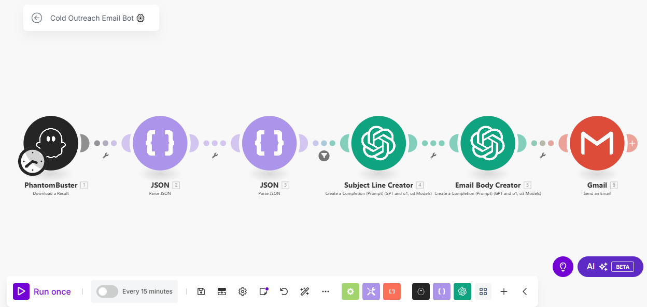

**Skills Used:** Email scraping, AI content generation, automation, and workflow optimization using Make.com. The bot integrates PhantomBuster for efficient email extraction and OpenAI's ChatGPT for intelligent email content creation.

**Relevant Outcomes/Achievements:** Successfully implemented a zero-coding, plug-and-play solution that runs on autopilot, making it accessible for users without technical expertise. The bot's ability to generate and send personalized emails every 15 minutes ensures consistent and effective outreach. This project has enabled users to enhance their email marketing strategies, leading to higher engagement rates and improved efficiency. The fully customizable nature of the bot allows users to tailor email content to specific audiences, ensuring relevance and impact.

**Key Features:**

* Automated scraping of targeted emails from LinkedIn.
* AI-driven generation of personalized subject lines and email bodies.
* Seamless integration with Gmail for email saving and sending.
* Fully customizable and adjustable to meet specific outreach requirements.
* Zero coding required, ensuring ease of use for non-technical users.